MADHAV INSTITUTE OF TECHNOLOGY & SCIENCE GWALIOR
(Deemed University)
(Declared under Distinct Category by Ministry of Education, Government of India)
NAAC Accredited with A++ Grade

Lab File Project Report
on
IMAGE PROCESSING (3240622)


SUBMITTED BY
Aditya parjapati
0901AD231004
VI Semester
Artificial Intelligence and Data Science

SUBMITTED TO
Dr. Tej Singh
Designation
Ms. Pooja Tripathi
Designation

CENTRE FOR ARTIFICIAL INTELLIGENCE
Session: 2026-2027

Table of Contents

Exp. No. | Title | Pg. No. | Date | Signature
1. | To study various signals in Python |  | 20/01/2026
2. | Negation of an image |  | 20/01/2026
3. | Thresholding of an Image |  | 27/01/2026
4. | Contrast Stretching of an Image |  | 27/01/2026
5. | Bit Plane Slicing |  | 03/02/2026
6. | Histogram Equalization |  | 03/02/2026
7. | Zooming by interpolation and replication |  | 10/02/2026
8. | Filtering in the spatial domain: Low-pass filtering |  | 10/02/2026
9. | To implement median filtering in the spatial domain after adding salt and pepper noise |  | 24/02/2026
10. | Edge Detection |  | 24/02/2026

Experiment 1:

Aim: To study and plot various basic signals using Python.
Theory:
A signal is a mathematical function representing a physical quantity.
Unit Step Function:
u(t) = 1 for t ≥ 0
u(t) = 0 for t < 0
Unit Impulse Function:
δ(t) = 1 at t = 0
δ(t) = 0 for t ≠ 0
Sine Wave:
x(t) = A sin(ωt + φ)
Exponential Signal:
x(t) = e^t
Algorithm:
- Generate a range of values for the time/independent axis using numpy.linspace.
- Define the mathematical logic for each signal (Sinusoidal, Logarithmic, Quadratic, etc.).
- Use matplotlib.subplot to create a grid of visualizations.
- Plot the signals and apply titles/labels.
Code:
import numpy as np
import matplotlib.pyplot as plt

# Generate time axis
x = np.linspace(-10, 10, 100)

plt.figure(figsize=(12, 8))

# 1. Sinc Function
plt.subplot(2, 3, 1)
plt.plot(x, np.sin(x)/x)
plt.title("sinc(x)")

# 2. Exponential Growth
plt.subplot(2, 3, 2)
plt.plot(x, 2**x + 3)
plt.title("2^x + 3")

# 3. Logarithmic Signal
plt.subplot(2, 3, 3)
plt.plot(x, np.log(np.abs(x) + 1))
plt.title("log(|x|+1)")

# 4. Trigonometric (Tan)
plt.subplot(2, 3, 4)
plt.plot(x, np.tan(x))
plt.ylim(-10, 10)
plt.title("tan(x)")

# 5. Quadratic Signal
plt.subplot(2, 3, 5)
plt.plot(x, x**2 + x + 1)
plt.title("x^2 + x + 1")

# 6. Rational Function
plt.subplot(2, 3, 6)
plt.plot(x, (x**3 + x + 1)/(x**2 + 1))
plt.title("(x^3+x+1)/(x^2+1)")

plt.tight_layout()
plt.show()

Output:
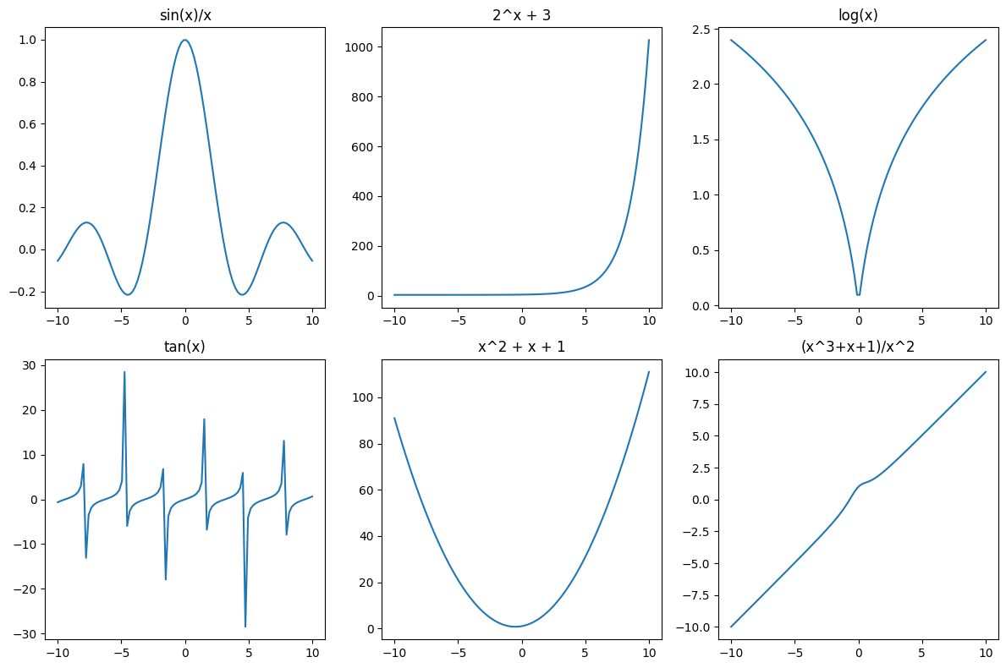

Experiment 2

Aim: To study and implement image negation.
Theory:
The negative of an image is used to enhance white or grey details embedded in dark regions.
For an image with intensity levels in the range [0, L-1], the transformation is:
s = (L - 1) - r
where r is the original pixel value, and s is the processed pixel value.
Algorithm:
- Load the input image using OpenCV.
- Convert the image from BGR to RGB color space for correct display in Matplotlib.
- Subtract each pixel intensity from the maximum possible value (255 for 8-bit images).
- Display the original and the negated image side-by-side.
Code:
import cv2
import numpy as np
import matplotlib.pyplot as plt

# Attempt to read the image
img = cv2.imread('test.jpg')

# Check if the image was loaded successfully
if img is None:
print("Warning: 'test.jpg' not found. Creating a dummy image for demonstration.")
# Create a dummy image (e.g., a grayscale image with a gradient)
img = np.zeros((200, 200, 3), dtype=np.uint8)
for i in range(200):
img[:, i] = [i, i, i] # A gradient from black to white

# Convert to RGB for matplotlib display
img_rgb = cv2.cvtColor(img, cv2.COLOR_BGR2RGB)

# Apply Negation: s = 255 - r
neg = 255 - img

plt.subplot(1, 2, 1)
plt.title("Original Image")
plt.imshow(img_rgb)

plt.subplot(1, 2, 2)
plt.title("Negative Image")
plt.imshow(cv2.cvtColor(neg, cv2.COLOR_BGR2RGB))

plt.show()

Output:
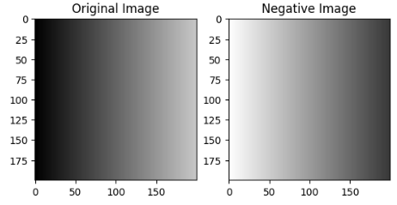

Experiment 3
Aim: To study image thresholding and conversion to binary form.
Theory:
Thresholding is a segmentation method that converts a grayscale image into a binary image.
s = L - 1, if r > T
s = 0, if r ≤ T
where T is the threshold value.
Algorithm:
- Read the image in grayscale mode.
- Define a threshold value (e.g., the midpoint of the intensity range).
- Compare every pixel to the threshold; set to 255 if greater, else 0.
- Display the resulting binary image.
Code:
import cv2
import numpy as np
import matplotlib.pyplot as plt

img = cv2.imread('test2.jpg', 0)

r1, r2 = 70, 140
s1, s2 = 0, 255

result = np.zeros_like(img)

for i in range(img.shape[0]):
for j in range(img.shape[1]):
r = img[i,j]
if r <= r1:
result[i,j] = s1/r1 * r
elif r <= r2:
result[i,j] = ((s2-s1)/(r2-r1))*(r-r1)+s1
else:
result[i,j] = ((255-s2)/(255-r2))*(r-r2)+s2

# Show input and output side by side
plt.figure(figsize=(10,5))

plt.subplot(1,2,1)
plt.imshow(img, cmap='gray')
plt.title("Input Image")
plt.axis('off')

plt.subplot(1,2,2)
plt.imshow(result, cmap='gray')
plt.title("Output Image")
plt.axis('off')

plt.tight_layout()
plt.show()

Output:
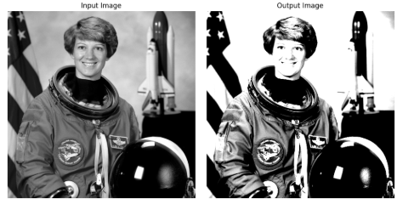

Experiment 4
Aim: To study and implement contrast stretching using a piecewise linear transformation.
Theory:
Contrast stretching increases the dynamic range of gray levels in the processed image.

It maps the input intensity range (r1, r2) to the output range (s1, s2), thereby improving image contrast.
Algorithm:
- Read the image and define control points (r1, s1) and (r2, s2).
- Iterate through every pixel.
- Apply linear equations based on the pixel's current range:
  - 0 → r1
  - r1 → r2
  - r2 → 255
- Output the stretched image.
Code:
import cv2
import numpy as np
import matplotlib.pyplot as plt

img = cv2.imread('test.jpg', 0)

r1, r2 = 70, 140
s1, s2 = 0, 255

result = np.zeros_like(img)

for i in range(img.shape[0]):
for j in range(img.shape[1]):
r = img[i, j]
if r <= r1:
result[i, j] = (s1 / r1) * r
elif r <= r2:
result[i, j] = ((s2 - s1) / (r2 - r1)) * (r - r1) + s1
else:
result[i, j] = ((255 - s2) / (255 - r2)) * (r - r2) + s2

plt.figure(figsize=(10, 5))
plt.subplot(1, 2, 1)
plt.title("Original")
plt.imshow(img, cmap='gray')

plt.subplot(1, 2, 2)
plt.title("Contrast Stretched")
plt.imshow(result, cmap='gray')
plt.show()

ouptut:-

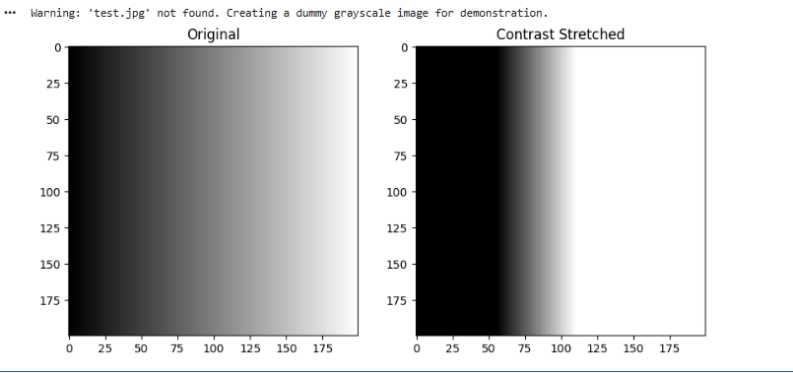

Experiment 5
Aim: To extract and study different bit planes of an 8-bit image.
Theory:
An 8-bit image is composed of 8 binary planes. Plane 0 contains the Least Significant Bit (LSB), and Plane 7 contains the Most Significant Bit (MSB). MSBs carry the most visual information.
Algorithm:
- Load a grayscale image.
- Use bitwise right shift and bitwise AND operations to extract bits.
- Multiply the extracted bit (0 or 1) by 255 for visualization.
- Display all 8 planes in a grid.
Code:
import cv2
import numpy as np
import matplotlib.pyplot as plt

img = cv2.imread('test.jpg', 0)

plt.figure(figsize=(15, 6))
plt.subplot(2, 5, 1)
plt.imshow(img, cmap='gray')
plt.title("Original")

for k in range(8):
bit_plane = (img >> k) & 1
plt.subplot(2, 5, k + 2)
plt.imshow(bit_plane * 255, cmap='gray')
plt.title(f"Bit Plane {k}")

plt.tight_layout()
plt.show()

Output:
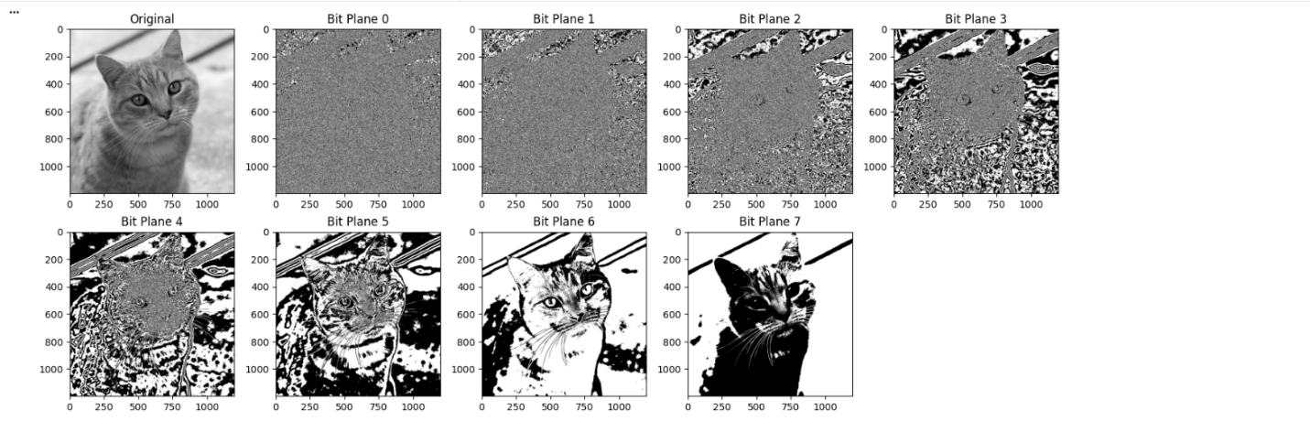

Experiment 6
Aim: To implement histogram equalization to enhance image contrast.
Theory:
Histogram equalization spreads out the most frequent intensity values. It uses the Cumulative Distribution Function (CDF) to map the input intensities to a uniform output distribution.
Algorithm:
- Calculate the histogram of the image.
- Compute the Cumulative Sum of the histogram (CDF).
- Normalize the CDF to the range [0, 255].
- Map the original pixel values to the new values using the normalized CDF.
Code:
import numpy as np
import cv2
import matplotlib.pyplot as plt

# Read image
img = cv2.imread('cameraman.jpg', cv2.IMREAD_GRAYSCALE)

# Flatten image
flat = img.flatten()

# Function to calculate histogram
def get_histogram(image, bins):
histogram = np.zeros(bins)
for pixel in image:
histogram[pixel] += 1
return histogram

# Get histogram
hist = get_histogram(flat, 256)

# Cumulative sum function
def cumsum(a):
a = iter(a)
b = [next(a)]
for i in a:
b.append(b[-1] + i)
return np.array(b)

# Get cumulative distribution function
cdf = cumsum(hist)

# Normalize CDF
cdf_normalized = (cdf - cdf.min()) * 255 / (cdf.max() - cdf.min())
cdf_normalized = cdf_normalized.astype('uint8')

# Map original image pixels to equalized values
img_eq = cdf_normalized[img]

# ---------------- PLOTTING ---------------- #

plt.figure(figsize=(10,8))

# Input Image
plt.subplot(2,2,1)
plt.imshow(img, cmap='gray')
plt.title("Input Image")
plt.axis('off')

# Output Image
plt.subplot(2,2,2)
plt.imshow(img_eq, cmap='gray')
plt.title("Equalized Image")
plt.axis('off')

# Input Histogram
plt.subplot(2,2,3)
plt.title("Input Histogram")
plt.hist(flat, bins=50)

# Output Histogram
plt.subplot(2,2,4)
plt.title("Equalized Histogram")
plt.hist(img_eq.flatten(), bins=50)

plt.tight_layout()
plt.show()

Output:

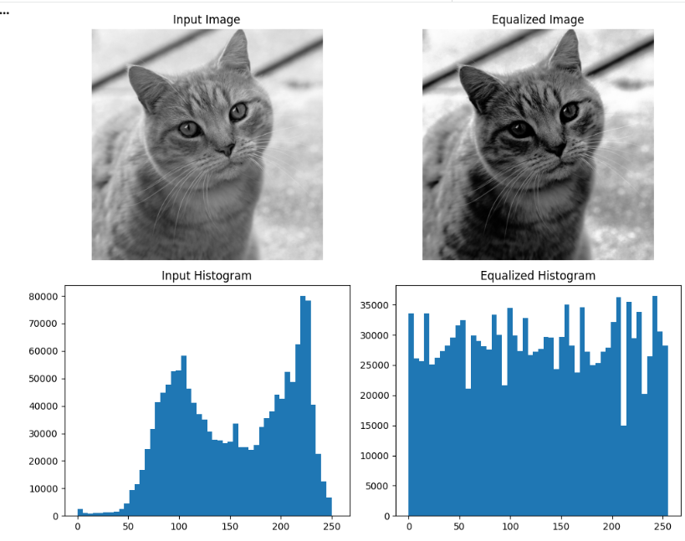

Experiment 7
Aim: To perform image zooming using Pixel Replication and Linear Interpolation.
Theory:
- Replication: Each pixel is repeated N times.
- Interpolation: New pixel values are calculated by averaging neighbors, resulting in smoother transitions.
Algorithm:
- Load an image.
- Apply numpy.repeat for pixel replication.
- Apply cv2.resize with linear interpolation.
- Compare the sharpness and blockiness of both methods.
Code:
import cv2
import numpy as np
import matplotlib.pyplot as plt

img = cv2.imread('cameraman.jpg', cv2.IMREAD_GRAYSCALE)

# Replication using numpy repeat (correct + efficient)
replicated = np.repeat(np.repeat(img, 2, axis=0), 2, axis=1)

plt.figure(figsize=(8,4))

plt.subplot(1,2,1)
plt.title("Original Image")
plt.imshow(img, cmap='gray')
plt.axis('off')

plt.subplot(1,2,2)
plt.title("Replication Zoom")
plt.imshow(replicated, cmap='gray')
plt.axis('off')

plt.tight_layout()
plt.show()

img = cv2.imread('cameraman.jpg', cv2.IMREAD_GRAYSCALE)

# Create empty enlarged image
h, w = img.shape
interp = np.zeros((2*h, 2*w), dtype=np.uint8)

# Copy original pixels
interp[::2, ::2] = img

# Row interpolation
interp[1::2, ::2] = (img[:-1, :] + img[1:, :]) // 2

# Column interpolation
interp[::2, 1::2] = (img[:, :-1] + img[:, 1:]) // 2

# Diagonal interpolation
interp[1::2, 1::2] = (
img[:-1, :-1] + img[1:, :-1] +
img[:-1, 1:] + img[1:, 1:]
) // 4

plt.figure(figsize=(8,4))

plt.subplot(1,2,1)
plt.title("Original Image")
plt.imshow(img, cmap='gray')
plt.axis('off')

plt.subplot(1,2,2)
plt.title("Interpolation Zoom")
plt.imshow(interp, cmap='gray')
plt.axis('off')

plt.tight_layout()
plt.show()

Output:
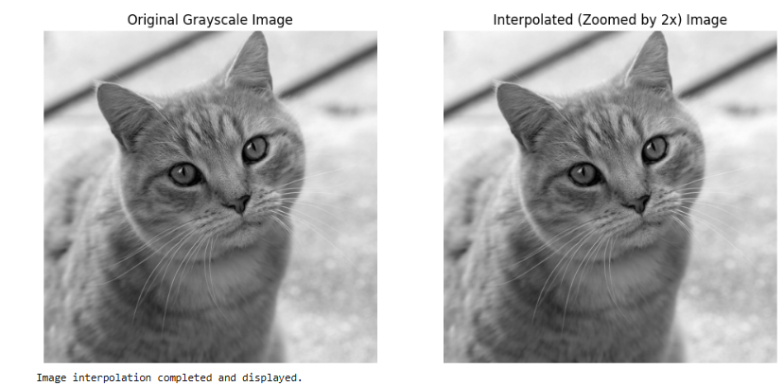

Experiment 8
Aim: To implement a low-pass filter for image smoothing.
Theory:
Low-pass filters smooth the image by reducing noise and fine details.

The 3 × 3 averaging mask is:

[1 1 1
1 1 1
1 1 1] × (1/9)
Algorithm:
- Load a grayscale image.
- Create an N times N kernel filled with 1/N^2.
- Convolve the kernel with the image using cv2.filter2D.
- Display the blurred result.
Code:
import numpy as np
import cv2
import matplotlib.pyplot as plt

# Read image
img = cv2.imread('cameraman.jpg', cv2.IMREAD_GRAYSCALE)

# Show original image
plt.figure(figsize=(10,4))

plt.subplot(1,3,1)
plt.title("Original")
plt.imshow(img, cmap='gray')
plt.axis('off')

# Padding
padded = np.pad(img, pad_width=1, mode='constant', constant_values=0)

# ---------------- MEAN FILTER ---------------- #
mean_img = np.zeros_like(img, dtype=np.uint8)

for i in range(img.shape[0]):
for j in range(img.shape[1]):
mean_img[i, j] = np.sum(padded[i:i+3, j:j+3]) / 9

# ---------------- MEDIAN FILTER ---------------- #
median_img = np.zeros_like(img, dtype=np.uint8)

for i in range(img.shape[0]):
for j in range(img.shape[1]):
median_img[i, j] = np.median(padded[i:i+3, j:j+3])

# ---------------- PLOTTING ---------------- #

plt.subplot(1,3,2)
plt.title("Mean Filter")
plt.imshow(mean_img, cmap='gray')
plt.axis('off')

plt.subplot(1,3,3)
plt.title("Median Filter")
plt.imshow(median_img, cmap='gray')
plt.axis('off')

plt.tight_layout()
plt.show()
Output:

Experiment 9
Aim: To add salt-and-pepper noise and remove it using a median filter.
Theory:
Salt-and-pepper noise appears as random white and black pixels. The median filter is a non-linear filter that effectively removes this noise by replacing a pixel with the median value of its neighborhood.
Algorithm:
- Create a noisy image by randomly assigning pixels to 0 (pepper) or 255 (salt).
- Apply the cv2.medianBlur function.
- Observe how the median filter preserves edges while removing impulsive noise.
Code:
import numpy as np
import cv2
import random
import matplotlib.pyplot as plt

# Read image
img = cv2.imread('cameraman.jpg', cv2.IMREAD_GRAYSCALE)

# ---------------- SALT & PEPPER NOISE FUNCTION ---------------- #
def sp_noise(image, prob):
output = np.zeros(image.shape, np.uint8)
thres = 1 - prob

for i in range(image.shape[0]):
for j in range(image.shape[1]):
rdn = random.random()
if rdn < prob:
output[i][j] = 0
elif rdn > thres:
output[i][j] = 255
else:
output[i][j] = image[i][j]

return output

# Add noise
noisy_img = sp_noise(img, 0.02)

# Padding for filtering
padded = np.pad(noisy_img, pad_width=1, mode='constant', constant_values=0)

# ---------------- MEDIAN FILTER ---------------- #
filtered = np.zeros_like(img)

for i in range(img.shape[0]):
for j in range(img.shape[1]):
filtered[i][j] = np.median(padded[i:i+3, j:j+3])

# ---------------- DISPLAY ---------------- #
plt.figure(figsize=(8,4))

plt.subplot(1,2,1)
plt.title("Noisy Image (S&P)")
plt.imshow(noisy_img, cmap='gray')
plt.axis('off')

plt.subplot(1,2,2)
plt.title("After Median Filter")
plt.imshow(filtered, cmap='gray')
plt.axis('off')

plt.tight_layout()
plt.show()

Output:
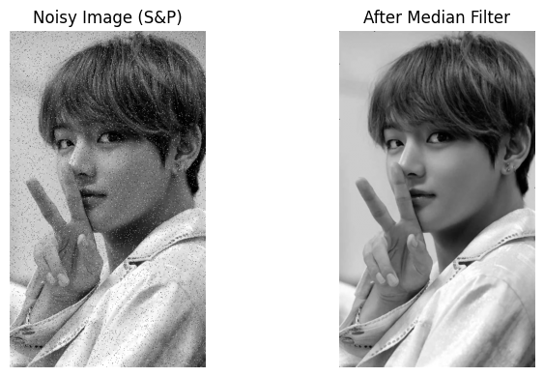

Experiment 10
Aim: To perform edge detection using Sobel and Laplacian operators.
Theory:
Edges correspond to sharp changes in intensity.
- Sobel: Uses first-order derivatives to find gradients in X and Y directions.
- Laplacian: Uses second-order derivatives to find regions of rapid intensity change.
Algorithm:
- Load image in grayscale.
- Apply cv2.Sobel for horizontal and vertical edges.
- Apply cv2.Laplacian for omnidirectional edge detection.
- Visualize the gradients.
Code:
import cv2
import numpy as np
import matplotlib.pyplot as plt

# Read image
img = cv2.imread('cameraman.jpg', cv2.IMREAD_GRAYSCALE)

# Padding
padded = np.pad(img, pad_width=1, mode='constant', constant_values=0)

# Output arrays
sobelX = np.zeros_like(img, dtype=np.float32)
sobelY = np.zeros_like(img, dtype=np.float32)
prewittX = np.zeros_like(img, dtype=np.float32)
prewittY = np.zeros_like(img, dtype=np.float32)
laplacian = np.zeros_like(img, dtype=np.float32)

# Kernels (corrected)
sobelGx = np.array([[-1,0,1],[-2,0,2],[-1,0,1]])
sobelGy = np.array([[-1,-2,-1],[0,0,0],[1,2,1]])

prewittGx = np.array([[-1,0,1],[-1,0,1],[-1,0,1]])
prewittGy = np.array([[-1,-1,-1],[0,0,0],[1,1,1]])

laplacianG = np.array([[0,-1,0],[-1,4,-1],[0,-1,0]])

# Convolution
for i in range(img.shape[0]):
for j in range(img.shape[1]):
region = padded[i:i+3, j:j+3]

sobelX[i,j] = np.sum(region * sobelGx)
sobelY[i,j] = np.sum(region * sobelGy)

prewittX[i,j] = np.sum(region * prewittGx)
prewittY[i,j] = np.sum(region * prewittGy)

laplacian[i,j] = np.sum(region * laplacianG)

# Convert to displayable format
sobelX = np.abs(sobelX)
sobelY = np.abs(sobelY)
prewittX = np.abs(prewittX)
prewittY = np.abs(prewittY)
laplacian = np.abs(laplacian)

# ---------------- DISPLAY ---------------- #

# Sobel
plt.figure(figsize=(10,4))
plt.subplot(1,3,1)
plt.title("Original")
plt.imshow(img, cmap='gray')
plt.axis('off')

plt.subplot(1,3,2)
plt.title("Sobel Gx")
plt.imshow(sobelX, cmap='gray')
plt.axis('off')

plt.subplot(1,3,3)
plt.title("Sobel Gy")
plt.imshow(sobelY, cmap='gray')
plt.axis('off')

plt.tight_layout()
plt.show()

# Prewitt
plt.figure(figsize=(10,4))
plt.subplot(1,3,1)
plt.title("Original")
plt.imshow(img, cmap='gray')
plt.axis('off')

plt.subplot(1,3,2)
plt.title("Prewitt Gx")
plt.imshow(prewittX, cmap='gray')
plt.axis('off')

plt.subplot(1,3,3)
plt.title("Prewitt Gy")
plt.imshow(prewittY, cmap='gray')
plt.axis('off')

plt.tight_layout()
plt.show()

# Laplacian
plt.figure(figsize=(8,4))
plt.subplot(1,2,1)
plt.title("Original")
plt.imshow(img, cmap='gray')
plt.axis('off')

plt.subplot(1,2,2)
plt.title("Laplacian")
plt.imshow(laplacian, cmap='gray')
plt.axis('off')

plt.tight_layout()
plt.show()

Output:
